LANGUAGE: bash/shell, Python

TOPICS: command-line interface, Python interpreter

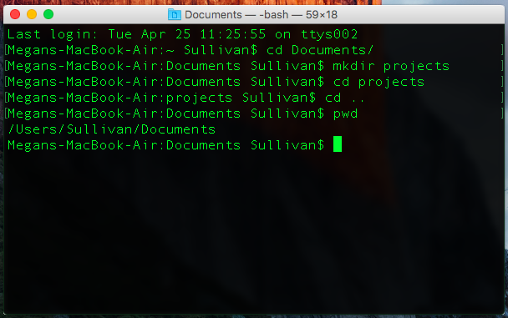

## OVERVIEW

The computer’s command-line interface (called Terminal on Mac, or Command Prompt on Windows) is a tool that you can use to interact with your computer without using the graphical user interface.

### CONTEXT

Back in the day, before graphical user interfaces (GUI) were created, programmers had to use the command-line interface (CLI) to interact with the computer. Now, engineers still use CLIs because they’re faster and use fewer of the computer’s system resources than a GUI.

## INSTRUCTIONS

### SUMMARY

* Open the command-line interface on your computer.
  + On Mac machines, open the **Terminal** application.
  + On Windows machines, open the **Command Prompt** application.
* Fill out the table on the next page by entering the specified commands into your command prompt. Note that some of the commands look different on Mac vs. Windows!

**NOTES**

* **Command** column: What to type into the command-line interface.
  + Unless otherwise noted, commands work on both Mac and Windows.
  + Things in brackets [] should be replaced by you.
    - E.g. cd [foldername] -> cd Documents
* **Output** column: What gets displayed after you hit enter (if anything)?
* **What It Does** column: In your own words, explain what the command does.

**COMMAND-LINE COMMANDS**

|  |  |  |
| --- | --- | --- |
| **Command** | **Output** | **What It Does** |
| Mac:  pwd  Windows:  cd | Changes directory  /Users/emilysimens |  |
| cd [foldername] | Tells contents of directory |  |
| cd .. |  |  |
| Mac:  ls  Windows:  dir |  |  |
| Mac:  python3  Windows:  python |  |  |

**PYTHON INTERPRETER COMMANDS**

|  |  |  |
| --- | --- | --- |
| **Command** | **Output** | **What It Does** |
| 14 + 1 |  |  |
| "apple" + "banana" |  |
| "25" + 16 |  |
| 6 / 2 |  |  |
| 5 / 2 |  |
| 5 // 2 |  |  |
| 9 % 3 |  |  |
| 8 % 3 |  |
| 7 % 3 |  |
| 6 % 3 |  |
| 10 * 4 |  |  |
| 10 ** 4 |  |  |
| 5 == 5 |  |  |
| "5" == 5 |  |
| 5 == 12 |  |
| 3 != 3 |  |  |
| "3" != 3 |  |
| 26 != 7 |  |
| 16 < 3 |  |  |
| 9 < 2 |  |
| 25 > 8 |  |  |
| 5 > 29 |  |
| True and True |  |  |
| True and False |  |
| False and True |  |
| False and False |  |
| True or True |  |  |
| True or False |  |
| False or True |  |
| False or False |  |
| not False |  |  |
| not True |  |
| exit() |  |  |

## 

## REFERENCE

### SELECTED DOCUMENTATION

pwd

* Prints the present working directory (i.e. the path to the folder you are currently in).

cd [directorypath]

* Changes the current directory to the directory specified.

..

* Placeholder for the current value’s parent directory. For example, if you wanted to change to the current folder’s parent directory, you would type:  
  cd ..

ls (Mac) / dir (Windows)

* Lists all the files in the current directory.

python3 (Mac) / python (Windows)

* Opens the Python interpreter.